estec

European Space Research

and Technology Centre

Keplerlaan 1

2201 AZ Noordwijk

The Netherlands

T +31 (0)71 565 6565

F +31 (0)71 565 6040

www.esa.int

|  |
| --- |
| Progress Report / Status Report |

Monthly Report Intern Matteo De Benedetti - November 2019

Approval

|  |  |
| --- | --- |
| Title Monthly Report Intern Matteo De Benedetti - November 2019 | |
| Issue Number 0 | Revision Number 0 |
| Author Matteo De Benedetti | Date 02/12/2019 |
| Approved By | Date of Approval |
| Martin Azkarate |  |

Change Log

|  |  |  |  |
| --- | --- | --- | --- |
| Reason for change | Issue Nr. | Revision Number | Date |
| Creation of Document | 1 |  | 02/12/2019 |

Change Record

|  |  |  |  |
| --- | --- | --- | --- |
| Issue Number  0 | Revision Number  0 | | |
| Reason for change | Date | Pages | Paragraph(s) |
| Creation of Document | 02/12/2019 | All | All |

Distribution

|  |  |  |
| --- | --- | --- |
| Name/Organisational Unit | | |
| Martin Azkarate, TEC-MMA, ESA-ESTEC |
| Mario Innocenti, Robotics and Automation Engineering, University of Pisa |

Table of contents:

1 Introduction 4

1.1 Scope of the Document 4

2 REFINEMENT OF THE SPARTAN VO 4

2.1 Initial and Final Error 4

2.2 Inclusion of the IMU Samples 5

2.3 Refinement of the body-camera transformation 9

3 samples fetching rover scenario 10

3.1 Mars Sample Return Mission Introduction 10

3.2 Samples Fetching Rover 11

4 TesTS 12

4.1 Velocity 12

4.2 Exposure Time 12

4.3 Exposure Time and Speed 15

4.4 Low Ambient Light Scenario 17

5 References 21

5.1 Reference Documents 21

5.2 List of Acronyms 21

5.3 Table of Figures 21

# Introduction

## Scope of the Document

This document reports the work done by the author, Matteo De Benedetti, during his third month as an intern in the Planetary Robotics Lab (PRL) at the European Space Research and Technology Centre (ESTEC).

# REFINEMENT OF THE SPARTAN VO

## Initial and Final Error

The SpartanVO was initially evaluated on 5 sequences where the ExoTer Rover moved forward for 5 meters at increasing translational velocities.



Figure : Spartan VO velocity tests

Velocities:   
test1: 0.01 m/s  
test2: 0.03 m/s   
test3: 0.05 m/s  
test4: 0.07 m/s  
test5: 0.09 m/s

The results clearly show an initial and constant error proportional to the velocity, which then drops at the end of the rover traverse.

Many possible sources of this behaviour were investigated (such as a numerical error in the transformations, problems with a sudden acceleration, skipping some of the frames during acceleration) and it was found that the cause was a misalignment of the timestamps of the Vicon poses (which serve as Ground Truth) and the VO estimates.

Initially the VO estimates and Vicon poses had their timestamp set at logging time. This creates a delay in the VO estimates timestamp given by the computation time of the VO itself, and during this time the rover would keep moving and create this offset proportional to the velocity. When the rover stops this delay itself would not disappear, but since the rover is not moving anymore there would be no error in the position estimate.

To solve this problem the VO estimate timestamps have been set to the moment the second pair of stereo image used for the computation is captured. Since the Vicon samples have a frequency of around 100 Hz, which is considerably higher than the VO frequency, the VO estimates are then compared against an interpolated version of the Vicon samples, with new data-point aligned to the VO estimates timestamps.

The following picture shows how the solution completely solved the problem.



Figure : Solving the timestamp misalignment

## Inclusion of the IMU Samples

The ExoTer rover mounts an Inertial Measurement Unit (Sensonor stim300 [RD03]) that is used, among other things, to refine the VO estimates of Viso2 [RD04], the previous VO library that was tested.

The fusion of the SpartanVO samples with the IMU measurement has been implemented, following the same strategy of the existing component used by the Viso2 library.

The component takes as inputs the delta-pose in body reference frame of the rover from two consecutive poses computed by the VO and the orientation measured by the IMU in its own reference frames.

The IMU provides a very precise measurement of the absolute roll and pitch angles, while the heading reading is not as accurate and will not be used.

The delta-pose is then projected in an Odometry reference frames, which is centred on the body frame, with the z-axis aligned with the Gravity vector (therefore also with the z-axis of the IMU frame) and rotated about the y-axis and x-axis according to the rover pitch and roll respectively.

This projection is obtained by applying to the VO delta-pose a rotation given by the delta-roll and delta-pitch of the two IMU samples corresponding to the two consecutive poses of the VO.

This strategy allows the IMU orientation reading to be already expressed in the Odometry frame and requires only that the heading to be adjusted according to the first reading from Vicon, from the initial value of zero relative to the beginning of the motion.

Finally, the pose expressed in the Odometry frame then only needs a translation component, given by the first sample received from Vicon, and a rotation on the xy-plane according to the heading to be expressed in the World frame of the Test Bed in the PRL lab.

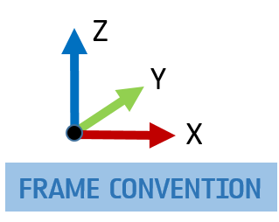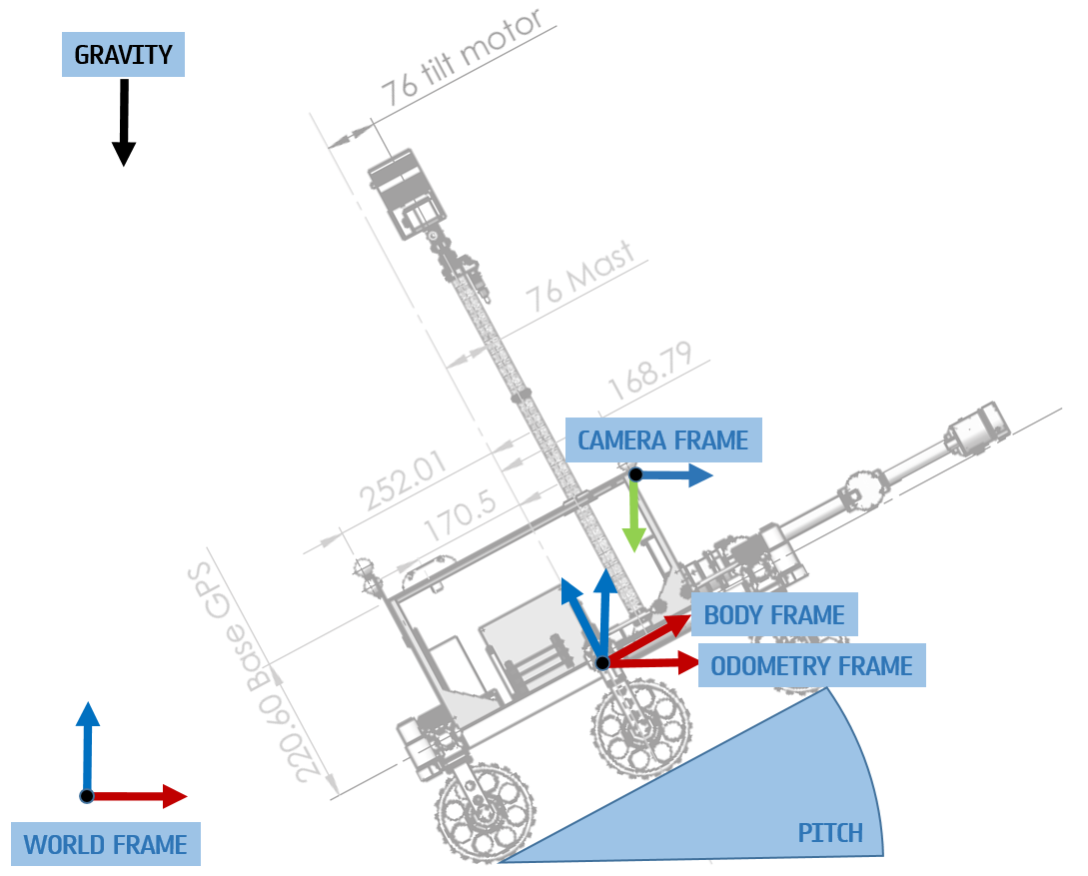

Figure : Side View of ExoTer with the reference frames

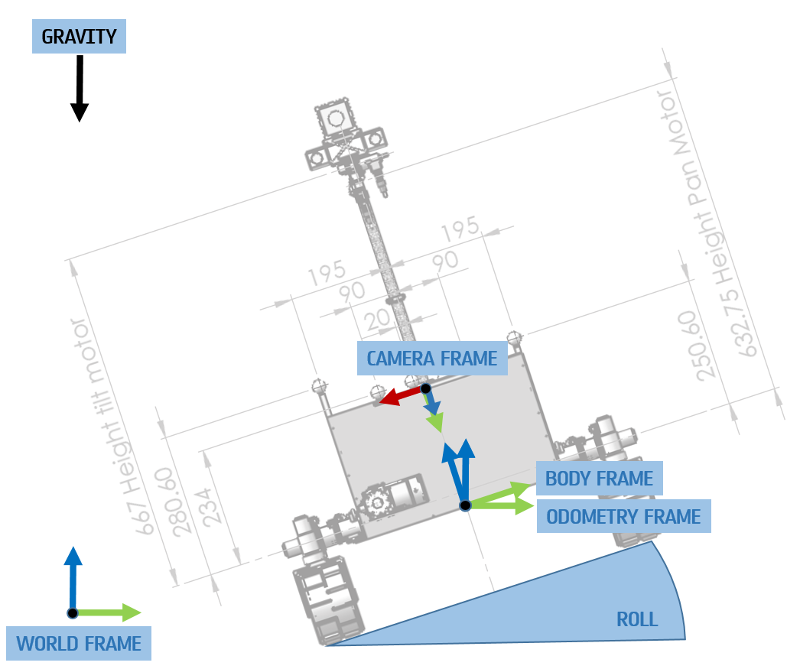

Figure : Front View of ExoTer with the reference frames

The new SpartanVO with IMU has then been tested in the Lab and an offset in the IMU readings was spotted.

After comparing said readings with an inclinometer it was decided that the reason for this offset did not belong in the IMU itself but a slight miscalibration the Vicon System and in the frame attached to the rover that Vicon uses to compute the pose.

A recalibration of the Vicon System has been performed and the frame attached to the ExoTer rover recreated and saved in the system, this significantly reduced the offset in the pitch and roll angles from a few degrees to less than 0.5 degrees in both as shown in the plots on the right (after the recalibration of Vicon and the new ExoTer object) compared to the two on the left.





Figure : Pitch and Roll errors before (left) and after (right) Vicon recalibration

The SpartanVO with IMU has then been tested and compared with the previous implementation without the IMU and it proved to be better in both orientation and position, as the following plots show (in the legends: test1 is pure Spartan, test2 is Spartan with IMU)



Figure : Position Error with and without IMU



Figure : Orientation Error with and without IMU

## Refinement of the body-camera transformation

To improve the SpartanVO performances, in addition to the IMU implementation, the body-camera transform has been refined.

Using the same test sequence, many experiments were run varying both the position and orientation of the transform, first using a variation step of 1 degree and 1 cm to find a good candidate, and then a much finer step of 0.1 degree and 1 mm to refine it.

The final transform greatly improved the VO performances, in particular it almost removed the drift in the z component.



Figure : VO performances improvement after body-camera transformation refinement

# samples fetching rover scenario

## Mars Sample Return Mission Introduction

So far missions to Mars have made many exciting discoveries that have transformed our understanding of the planet, but the analysis have always been limited by the time, budget, and space constraints of spacecraft/rover sensors.

The next step is to bring back samples to Earth for detailed analysis in the sophisticated laboratories on Earth.

This will allow scientists to share resources and send samples to the best laboratories around the world, laboratories so complicated and heavy they would be impossible to take to Mars, also allowing scientists to verify results independently.

In addition, as our equipment improves and new advances are made, samples can be reanalysed and new information extracted – as continues to happen on lunar samples brought to Earth in 1969 and the 1970s.

Bringing samples from Mars is the logical next step for robotic exploration and it will require multiple missions that will be more challenging and more advanced than any robotic missions before.

ESA is working with NASA to explore mission concepts for an international Mars Sample Return campaign between 2026 and 2030.

Three launches will be necessary to accomplish landing, collecting, storing and finding samples and delivering them to Earth:

1. NASA’s Mars 2020 mission will explore the surface and rigorously document and store a set of samples in canisters in strategic areas to be retrieved later for the flight back to Earth.
2. A NASA launch will send the Sample Return Lander mission to land a platform near the Mars 2020 site. From there, a small and agile ESA rover, the Sample Fetch Rover (SFR), will head out to retrieve the cached samples.

Once it has collected them, it will return to the lander platform and load them into a single large canister on the Mars Ascent Vehicle (MAV).

This vehicle will perform the first lift-off from Mars and carry the container into Mars orbit.

1. ESA’s Earth Return Orbiter will be the next mission, timed to capture the sample container orbiting Mars. The samples will be sealed in a biocontainment system to prevent contaminating Earth with unsterilized material before being moved into an Earth entry capsule.

The spacecraft will then return to Earth, where it will release the entry capsule for the samples to end up in a specialised handling facility.

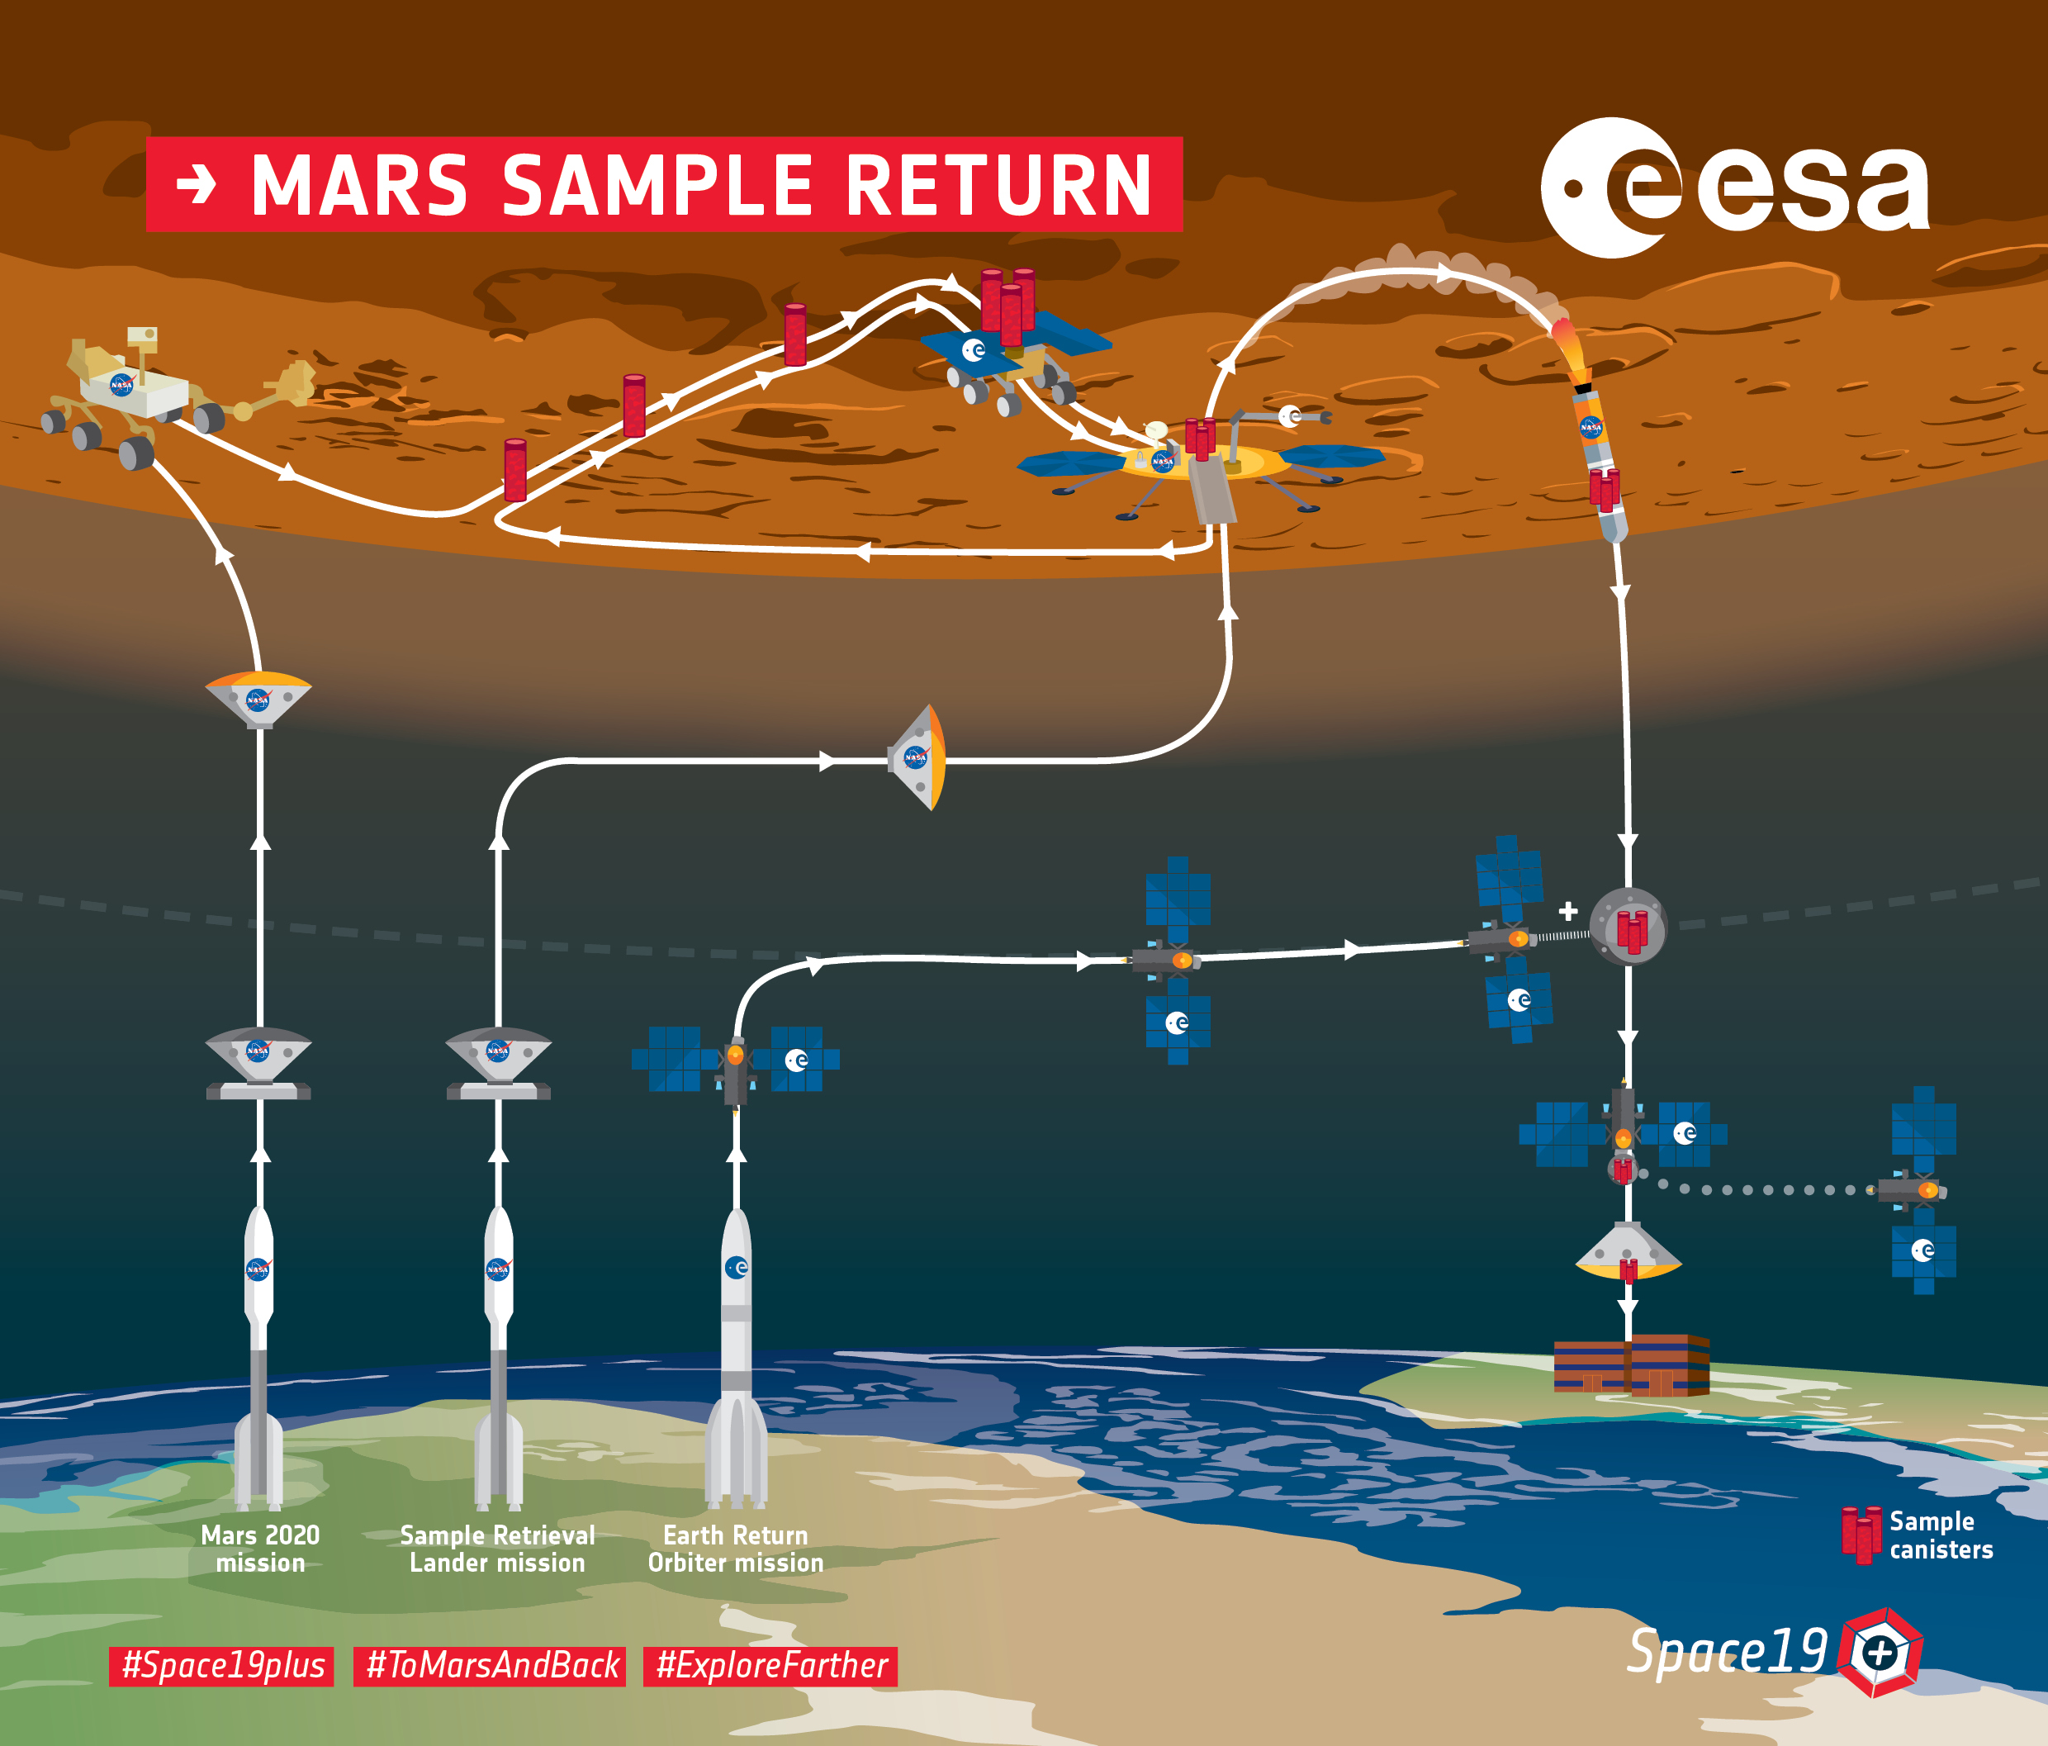

Figure : Mars Sample Return Overview

## Samples Fetching Rover

The MSR mission architecture places a number of challenging requirements on the SFR, extending beyond those in the assessment study. It requires a 125kg rover vehicle to traverse up to 30km within 155 sols [RD05].

The start of the SFR surface mission in the new mission architecture coincides with the Martian dust storm season, which means the SFR will need to able to maintain the same performances across a much higher optical depth.

The assigned mass of 125kg is approximately one third of the mass of ExoMars, which was instead designed to only traverse 4km in 200 Sols. This presents a significant challenge in terms of mobility, since a much higher speed is required.

At the moment the speed of the SFR is planned to be around 5-10cm/s in contrast with the 1cm/s required from ExoMars.

# TesTS

Since the translational velocity is one of the main differences of the SFR with respect to other rover missions it was decided to start the tests by varying it.

Nevertheless, it has been considered that the translational velocity has an effect on many other factors like the *inter-frame distance (in meters)* between two frames (which can be also influenced by the *frequency* that the VO runs at) the *blurriness* of the image (which can be mitigated decreasing the *exposure time*, at the cost of reduced *image brightness*, which also depends on the *ambient light*).

## Velocity

The first set of tests that has been run is made of sequences where the ExoTer rover moved forward for 5 meters at increasing translational velocities.



Figure : Velocity tests on Spartan VO with IMU

Velocities:   
test1: 0.01 m/s  
test2: 0.03 m/s   
test3: 0.05 m/s  
test4: 0.07 m/s  
test5: 0.09 m/s

Slope of the fitted line:   
test1: 0.0090  
test2: 0.0076  
test3: 0.0047  
test4: 0.0055  
test5: 0.0088

It has been noticed that it is more informative to look at the slopes of the error curve: a 1st degree polynomial has been fitted to the curve using Least Squares.

There is variation between the slopes of the tests, but it is not significant and more importantly does not look like it increases with the speed.

This leads to believe that only increasing the translational velocity, while all the other parameters (such as ambient light, VO frequency, exposure time of the camera etc.) remain the same, does not seem to have a negative effect on the VO performances.

## Exposure Time

Increasing the Exposure Time (ET) of the camera has two main effects:

* The image brightness will increase, which can be beneficial in case of a low ambient light.
* The motion blur will also increase, which is not beneficial for the VO since it adds uncertainty and noise in the features.

To measure the motion blur, rather than the visual inspection of the frames while the robot moves, a simple metric has been defined:

The image is filtered with a Laplacian kernel [0 1 0; 1 -4 1; 0 1 0] and then the maximum is taken.

For example, the image on the left is captured while the robot was moving at 0.07 m/s with ET=300ms while the image on the right at the same speed with ET=700ms.

The right image is clearly brighter but also the features (particularly the one in the bottom of the image, which have a higher velocity in the image plane) are considerably more blurred (it has a blurriness of 210 compared to 95 of the left image, according to the previously defined metric).

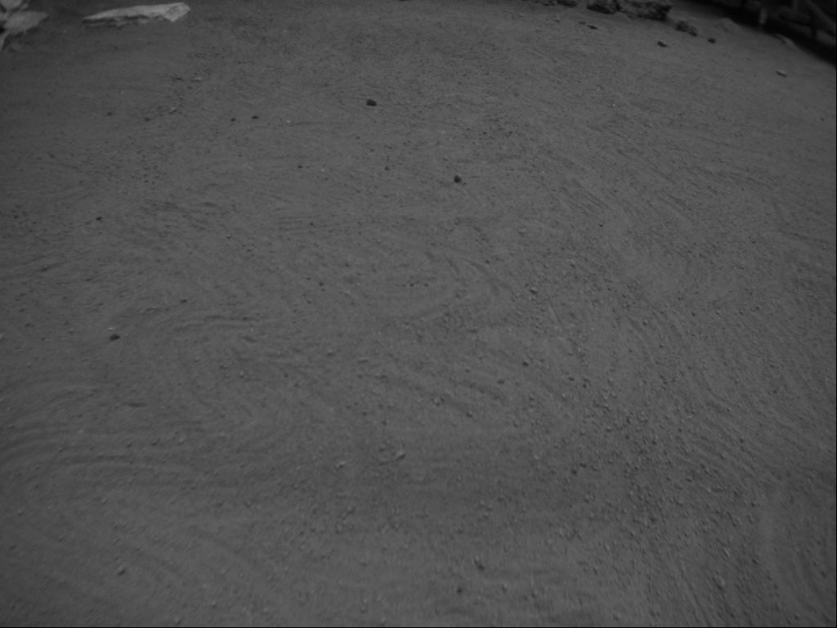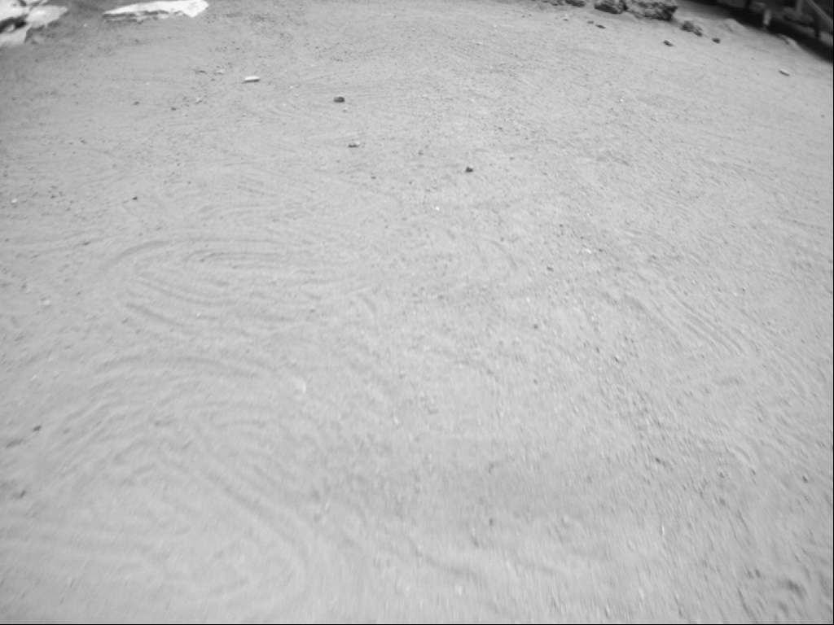

Figure : Low (left) and High (right) Exposure Times

The ExoTer camera (Bumblebee BB2-08S2C) has an Auto Exposure setting (AE) which internally computes an optimal value for the exposure time.

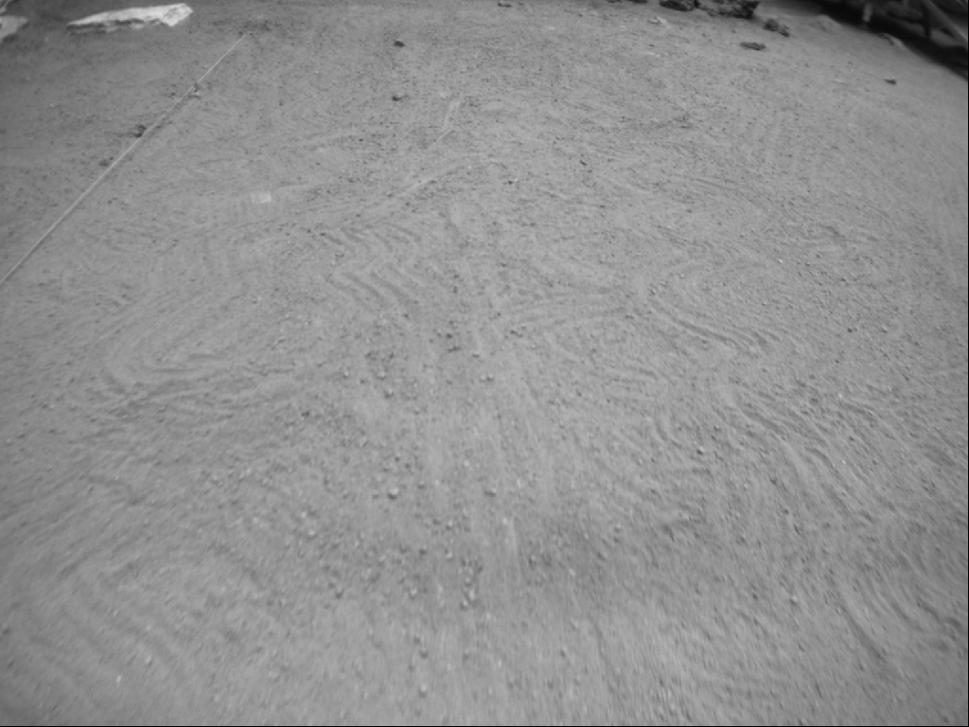

Figure : Auto Exposure

Different exposure times have been tested against a single constant velocity of 0.07 m/s (which, as mentioned before, is the velocity that the Sample Fetch Rover is designed to travel at) and the following results have been obtained.



test1 = auto-exposure  
test2: exposure time = 200 ms  
test3: exposure time = 300 ms  
test4: exposure time = 400 ms  
test5: exposure time = 500 ms  
test6: exposure time = 600 ms  
test7: exposure time = 700 ms



Figure : Position Error in the tests at different Exposure Times



Figure : Orientation Error in the tests at different Exposure Times

Test3 (that is ET=300ms) seems better than Test1 (that is AT, which is around 530ms).

This means that lowering the exposure time can be beneficial at high speeds because it helps reducing the motion blur, but if lowered too much it starts to be counterproductive because it also strongly reduces the brightness and contrast of the image (test2), while a high ET (test4-5-6-7) leads to an even higher motion blur that will negatively affect the VO performances and a too low ET (test2) gives an image that is too dark to produce a good VO estimate.

## Exposure Time and Speed

The previous tests showed that ET and speed are strongly related.

Therefore the following test was run to investigate the effect of reducing the exposure time also at lower speeds.



Figure : Comparison of the performances when reducing the ET at high and low speed



The results show that, while there is a beneficial effect (test1 is AE and test2 is ET=300ms) in reducing the ET at high speeds (0.07 m/s), in the case of a low speed traverse (0.02 m/s) reducing the ET does not yield an improvement in performance (test3 is AE and test4 is ET=300ms).

## Low Ambient Light Scenario

The low light/visibility scenario has been obtained by just switching off some of the lights in the lab and closing all the curtains of the windows in order to avoid external disturbances and to be able to replicate the same conditions in the future.

The ambient light has then been measured using a digital light meter (Flashmate L-308s) aimed at the ground of the Mars Test Bed from the same point of view as the rover’s camera and set in reflected-light mode (lumisphere away from the meter cell, ISO set to 100 and EV output) to better capture the amount of light that the camera is actually exposed to (which will then affect the image and the camera’s AE calculation).  
The sensor reading is in EV (Exposure Value) which can be easily transformed in lux with an exponential transformation: $LUX=2.5*2^{EV}$.

All the previous tests have been run with the lab fully lit at 422.2425 lux, while the low light scenario is at 226.2742 lux.

The first test that has been run in the low light scenario has the rover moving at 0.07 m/s and shows that the SpartanVO in AE was struggling (test1) and reducing the ET (test2) did not improve the performances.



Figure : Position Error when reducing the ET at high speed



Figure : Orientation Error when reducing the ET at high speed

The possibility of increasing the ET (test2), which would have the positive effect of increasing the brightness but also the negative effect of increasing the motion blur, has been also investigated.

The test clearly shows that it actually decreases the VO performances with respect to the use of AE (test1).



Figure : Position Error when increasing the ET at high speed



Figure : Orientation Error when increasing the ET at high speed

Finally, a low light and slow speed (0.02m/s) scenario has been tested.  
From the results it is clear that either increasing (test2) or decreasing (test3) the ET is not beneficial with respect to the use of AE (test1).



Figure : Position Error when reducing and increasing ET at low speed



Figure : Orientation Error when reducing and increasing ET at low speed

All these tests in the low light scenario show that low speed alone, in a low light scenario, is able to obtain better performances (xyz error norm of about 1mm) than a high speed traverse also changing the exposure time (xyz error norm of at least 6mm), because increasing it would make the image too dark, while decreasing it would make the effect of motion blur even stronger.

# References

## Reference Documents

|  |  |
| --- | --- |
| Reference | Document |
| [RD01] | ESA PRL GitHub, visodom branch, https://github.com/esa-prl/ |
| [RD02] | Personal GitHub, https://github.com/MatteoDeBenedetti/ESA-Thesis |
| [RD03] | Sensonor stim300 datasheet https://www.sensonor.com/media/1132/ts1524r9-datasheet-stim300.pdf |
| [RD04] | Viso2 Library, “Visual Odometry based on Stereo Image Sequences with RANSAC-based Outlier Rejection Scheme”, Bernd Kitt and Andreas Geiger and Henning Lategahn |
| [RD05] | “Engineering Challenges for a Sample Fetch Rover.” A. Wayman, M. Williams and P.  Meacham, Airbus, Gunnels Wood Road, Stevenage, SG12AS, UK |

## List of Acronyms

|  |  |
| --- | --- |
| Acronym | Full description |
| ESA | European Space Agency |
| ESTEC | European Space Research and Technology Centre |
| VO | Visual Odometry |
| PRL | Planetary Robotics Laboratory |
| ExoTer | ExoMars Testing Rover |
| MSR | Mars Sample Return |
| SFR | Sample Fetching Rover |
| MAV | Mars Ascent Vehicle |
| ET | Exposure Time (milliseconds) |
| AE | Auto Exposure mode of the camera |

## Table of Figures

Figure 1: Spartan VO velocity tests 4

Figure 2: Solving the timestamp misalignment 5

Figure 3: Side View of ExoTer with the reference frames 6

Figure 4: Front View of ExoTer with the reference frames 6

Figure 5: Pitch and Roll errors before (left) and after (right) Vicon recalibration 7

Figure 6: Position Error with and without IMU 8

Figure 7: Orientation Error with and without IMU 8

Figure 8: VO performances improvement after body-camera transformation refinement 9

Figure 9: Mars Sample Return Overview 11

Figure 10: Velocity tests on Spartan VO with IMU 12

Figure 11: Low (left) and High (right) Exposure Times 13

Figure 12: Auto Exposure 13

Figure 13: Position Error in the tests at different Exposure Times 14

Figure 14: Orientation Error in the tests at different Exposure Times 15

Figure 15: Comparison of the performances when reducing the ET at high and low speed 16

Figure 16: Position Error when reducing the ET at high speed 17

Figure 17: Orientation Error when reducing the ET at high speed 18

Figure 18: Position Error when increasing the ET at high speed 18

Figure 19: Orientation Error when increasing the ET at high speed 19

Figure 20: Position Error when reducing and increasing ET at low speed 19

Figure 21: Orientation Error when reducing and increasing ET at low speed 20